IT RCSA Audit Documentation
Access Certification 2025 Q3 PAM BSI SOX
  - Network Device Admin Account Review (BSI.IT.27.C7)
ASSESSMENT  FAIL | TEST PERIOD  JUL 2025 - JUN 2026 | EXCEPTIONS  A5 AND A6

Purpose
To document the IT RCSA review of the 2025 Q3 quarterly privileged access certification for BSI network devices (Sample 1 of 2 for the testing period July 1, 2025 - June 30, 2026, covering July - December 2025), including the privileged network AD groups defined in the PAM Definition of Privilege, the certification population reconciled to Active Directory, reviewer assignment (managers and account owners), review decisions, the appropriateness of approved access, revocation of inappropriate access within SLA, and compliance with the PAM Recertification Procedure and the IAM Standard.
Testing period | July 1, 2025 - June 30, 2026 (samples: 2025 Q3 and 2026 Q1)
Sample quarter | 2025 Q3 (quarterly PAM access certification) - Sample 1, covers July - December 2025
Certification | 2025 Q3 PAM BSI SOX Manager Certification and 2025 Q3 PAM BSI SOX Entitlement Owner Certification
Privileged groups sampled | CISCO ISE Administrators; CISCO Network Administrators; ISEAdmin; F5FullAdmin
Campaign launch | August 1, 2025 (Manager) / August 4, 2025 (Entitlement Owner)
Review decisions | 88 memberships: 55 Approved, 33 Revoked (decisions August 6 - August 28, 2025)
Overall conclusion | Not compliant - 14 memberships approved for terminated / disabled identities (A5) and 6 revoked memberships present again in AD (A6)

1. Executive Summary
IT RCSA reviewed the 2025 Q3 PAM BSI SOX access certification for the four privileged network AD groups defined in section 3.3 of the PAM Definition of Privilege, the BSI Active Directory extract of November 25, 2025 and the Netwrix revocation logs. All 88 memberships (78 users / administrators and 10 service accounts) were included in the certification and reconcile to Active Directory, were reviewed by the user's line manager or the account owner, and received a final decision between August 6 and August 28, 2025. However, 14 memberships in CISCO Network Administrators and ISEAdmin were approved for identities with an IAMS termination date of 12/31/2024 (E2), one of them also disabled in AD with no logon since October 15, 2023 (E1). The 33 memberships revoked on August 28, 2025 were removed between September 2 and 8, 2025 (within SLA), but 6 of them were members again in the AD extract of November 25, 2025 without an approved request (E3) - the removal was not sustained. The sample assessment result is Fail.

2. Sample and Scope
Privileged AD group | Memberships certified | User type | Scope result
CISCO ISE Administrators | 3 | 1 person / 2 service | Matched to AD
CISCO Network Administrators | 44 | 39 person / 5 service | Matched to AD
ISEAdmin | 36 | 35 person / 1 service | Matched to AD
F5FullAdmin | 5 | 3 person / 2 service | Matched to AD

3. Testing Performed and Results
Attribute | Evidence evaluated | Result | Conclusion
Frequency (A1) | Certifications in the period: 2025 Q3 (launched August 1, 2025) and 2026 Q1 (launched April 9, 2026); 2025 Q4 not provided. | Pass (observation) | One review in each half of the period (2025 Q3 covers July - December 2025); 2025 Q4 not evidenced (Procedure requires quarterly).
Population completeness (A2) | BSI AD extract November 25, 2025 compared to the 88 certified memberships. | Pass | All AD members certified except X842395 (added 8/30/2025) and MIA25172 / MIA25175 in ISEAdmin (added 9/10/2025) - added after launch and certified in 2026 Q1.
Reviewer (A3) | Decision makers compared to the identity, line manager and account owner. | Pass | Line managers (person) and owners (service accounts); no self-review.
Review completion (A4) | 88/88 memberships with a final decision; decisions August 6 - August 28, 2025. | Pass | Review completed and signed off.
Appropriateness of access (A5) | IAMS status in the certification and AD status (November 25, 2025) compared to approved memberships. | Fail | 14 memberships approved: E2 IAMS terminated 12/31/2024 MIA25103, MIA25104, MIA25105, MIA25106, MIA25249, MIA25250, MIA25251; E1 AD disabled MIA25103.
Revocation within SLA (A6) | 33 memberships revoked August 28, 2025; Netwrix removals September 2 - 8, 2025; AD extract November 25, 2025. | Fail | Removed within 30 business days, but 6 memberships (MIA25142, MIA25172, MIA25175, X453396) were members again on November 25, 2025 - removal not sustained, no approved request (E3).
Information reliability (A7) | Certification export, AD extract, Netwrix logs. | Pass (observation) | Reports reconcile; AD extract shows revoked members still present without comment; IAMS termination date inconsistent with AD expiration (01/01/2026).

Conclusion: The sampled certification is not compliant. Exceptions were identified in CISCO Network Administrators (A5 7, A6 4 of 44) and ISEAdmin (A5 7, A6 2 of 36); CISCO ISE Administrators and F5FullAdmin passed.

4. Referenced Excel Workbook - Tab-by-Tab Guide
Purpose. The referenced workbook (BSI.IT.27.C7.02 Q3_2025.xlsx, in BSI.IT.27.C7 Final 07.2025-06.2026 / 02 Evidence 07.2025-06.2026) contains the population, Active Directory and revocation evidence for this sample; BSI.IT.27.C7.05 Testing Walkthrough documents the testing step by step. The summary below allows a reviewer to trace each conclusion without interpreting the workbooks independently.
Workbook tab | What the tab contains / purpose | Reviewer use and sample traceability
Q3_2025 - NETWORK ADMINS | Extract of the PAM Definition of Privilege section 3.3 (March 2025). | Confirms the four groups in scope (Appendix A).
Q3_2025 - 1_Cisco ISE Administrators | AD extract November 25, 2025 with group members tagged. | 3 memberships certified and Approved; no exceptions.
Q3_2025 - 2_Cisco Network Administrators | AD extract; full 2025 Q3 SOX Manager and Owner certification exports; REVOCATION EVIDENCE (Netwrix). | 44 memberships; 18 revoked; A5 7, A6 4 exceptions. Exhibits B1, B3, B4.
Q3_2025 - 3_ISEAdmin | AD extract; REVOCATION EVIDENCE (Netwrix). | 36 memberships; 15 revoked; A5 7, A6 2 exceptions.
Q3_2025 - 4_F5FullAdmin | AD extract with group members tagged. | 5 memberships; no exceptions.
BSI.IT.27.C7.05 - 3_Attribute Matrix | Attribute table for Sample 1 (2025 Q3) and Sample 2 (2026 Q1). | Group-level results used in Section 3.
BSI.IT.27.C7.05 - 4_Item Detail / 5_Exceptions | Every membership with source row, IAMS and AD status and per-attribute result; exception trail per account. | Supports Section 3 and Appendix B.
Reviewer traceability
- Scope path: PAM Definition of Privilege section 3.3 -> NETWORK ADMINS tab -> group tabs 1-4 -> Appendix A.
- Population path: AD extract November 25, 2025 (tabs 1-4) -> 2025 Q3 certification (tab 2) -> Exhibit C1.
- Revocation path: certification decision Revoked -> Netwrix removal (tabs 2-3) -> AD extract November 25, 2025 -> Exhibit B4.
Note: The 2025 Q3 AD extract still shows 6 revoked memberships as group members; this was not commented on in the original evidence and is reported as exception A6 (E3).

5. Evidence Index and Audit Trail
Source | Purpose | Key support
BSI.IT.27.C7 Final 07.2025-06.2026 / 02 Evidence 07.2025-06.2026 / BSI.IT.27.C7.02 Q3_2025.xlsx | Sample population, decisions, AD, Netwrix | 2025 Q3 certification (launched 8/1/2025), AD extract 11/25/2025, Netwrix removals 9/2-9/8/2025.
BSI.IT.27.C7 Final 07.2025-06.2026 / 01 Policies and Procedures / PAM Recertification Procedure (BSI) 04.22.26.pdf (v2.0) | Procedure criteria | Control C7; quarterly SOX recertification; revocation for rejected / terminated users and PAM verification (v1.0 of 04/22/2025 in effect at the review date - same requirements).
BSI.IT.27.C7 Final 07.2025-06.2026 / 01 Policies and Procedures / BSI.IT.27.C7.01 Identity and Access Management Standard v10.0 09.29.2025.pdf | Review and revocation criteria | Approved 09/29/2025 (v9.0 applied at the August 2025 review - requested; requirements unchanged in v10.0 / v11.0): SUS.IAMS.4.2.5.1, 4.2.5.2, 4.2.5.5-4.2.5.7, 4.2.5.9, 4.2.5.10, 4.2.5.19 (privileged access at least semi-annually), 4.2.5.21 (revocation within 30 business days).
BSI.IT.27.C7 Final 07.2025-06.2026 / 01 Policies and Procedures / BSI.IT.27.C7.03 PAM Definition of Privilege.pdf (v10.0) | Scope criteria | Section 3.3 Network Administration.
BSI.IT.27.C7.05 Testing Walkthrough - Step by Step.xlsx | Step-by-step testing for the period | Both samples, item detail, exceptions, sources, evidence status.
WP2 BSI.IT.27.C7.xlsm | Testing workpaper | Control metadata, design assessment and performance assessment (2 samples, rating Needs Improvement).

6. Audit Conclusion
Based on the evidence reviewed, IT RCSA concluded that the 2025 Q3 PAM BSI SOX certification covered all members of the privileged network AD groups (reconciled to Active Directory), was performed by line managers and account owners with a recorded decision for every membership, and that revoked access was initially removed within SLA. However, the review approved privileged network access for identities terminated in IAMS (one also disabled in AD), and 6 revoked memberships were present again in AD on November 25, 2025, so inappropriate access was not identified or did not stay revoked. The control sample assessment result is Fail; together with Sample 2 (2026 Q1, Fail), the control performance for July 2025 - June 2026 is Needs Improvement.

Appendix A - PAM Definition of Privilege Evidence
Exhibit A1: PAM Definition of Privilege v10.0 - Section 3.3 Network Administration
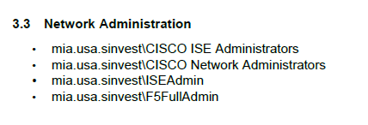
Source: BSI.IT.27.C7 Final 07.2025-06.2026 / 01 Policies and Procedures / BSI.IT.27.C7.03 PAM Definition of Privilege.pdf (page 7); NETWORK ADMINS tab of BSI.IT.27.C7.02 Q3_2025.xlsx

Appendix B - Certification Review Evidence
Exhibit B1: 2025 Q3 PAM BSI SOX Manager Certification - privileged network group memberships
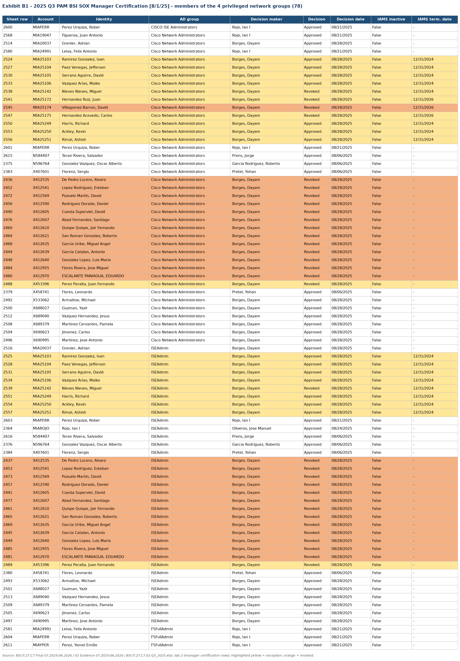
Source: BSI.IT.27.C7 Final 07.2025-06.2026 / 02 Evidence 07.2025-06.2026 / BSI.IT.27.C7.02 Q3_2025.xlsx (extract rendered from the source workbook)

Appendix B - Certification Review Evidence
Exhibit B2: 2025 Q3 PAM BSI SOX Entitlement Owner Certification - service accounts
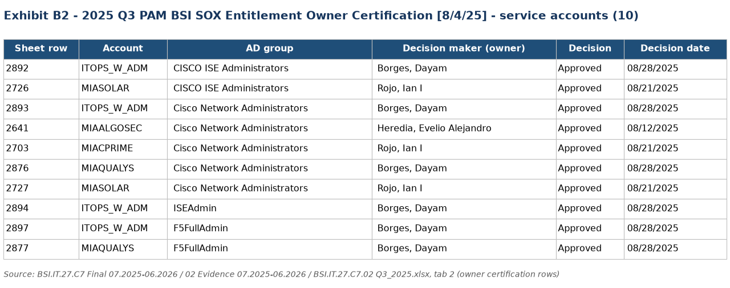
Source: BSI.IT.27.C7 Final 07.2025-06.2026 / 02 Evidence 07.2025-06.2026 / BSI.IT.27.C7.02 Q3_2025.xlsx (extract rendered from the source workbook)

Appendix B - Certification Review Evidence
Exhibit B3: IAMS and Active Directory status of the approved accounts in exception (E1 / E2)
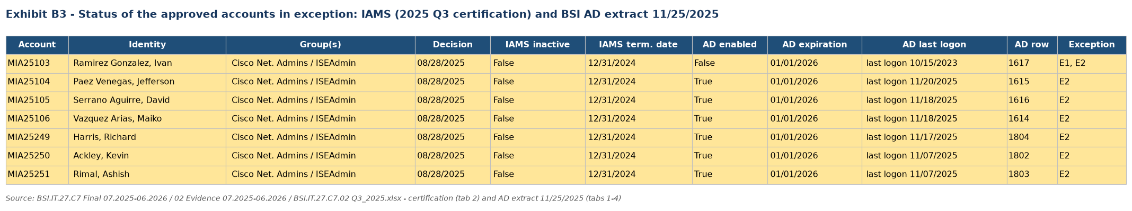
Source: BSI.IT.27.C7 Final 07.2025-06.2026 / 02 Evidence 07.2025-06.2026 / BSI.IT.27.C7.02 Q3_2025.xlsx (extract rendered from the source workbook)

Appendix B - Certification Review Evidence
Exhibit B4: 2025 Q3 revocations - Netwrix removal and AD November 25, 2025 (A6 / E3)
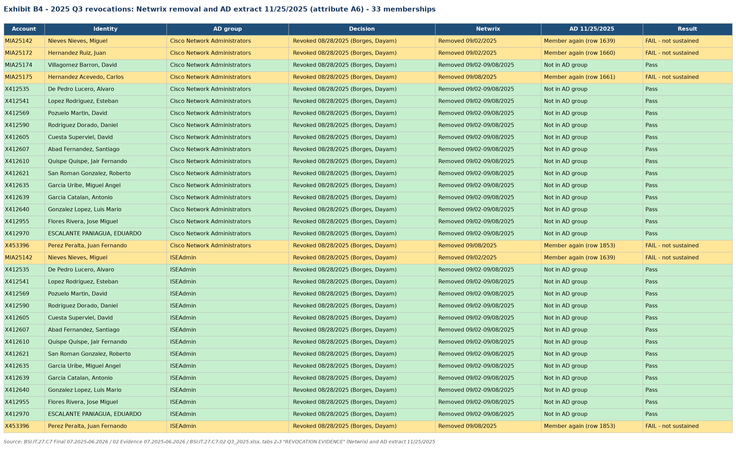
Source: BSI.IT.27.C7 Final 07.2025-06.2026 / 02 Evidence 07.2025-06.2026 / BSI.IT.27.C7.02 Q3_2025.xlsx (extract rendered from the source workbook)

Appendix C - Population and Frequency Evidence
Exhibit C1: Population completeness and certification frequency
The population and frequency were validated as follows:
- BSI AD extract November 25, 2025: every AD member of the four groups was certified in 2025 Q3 except members added after the launch (X842395 on 8/30/2025; MIA25172 / MIA25175 ISEAdmin on 9/10/2025), which were certified in 2026 Q1
- Certifications launched in the period: 2025 Q3 (August 1, 2025) and 2026 Q1 (April 9, 2026); 2025 Q4 not provided
Result: Pass (population); Pass with observation (frequency)
Conclusion: The population is complete; one review was performed in each half of the period; the missing 2025 Q4 quarterly review is reported as an observation pending evidence.
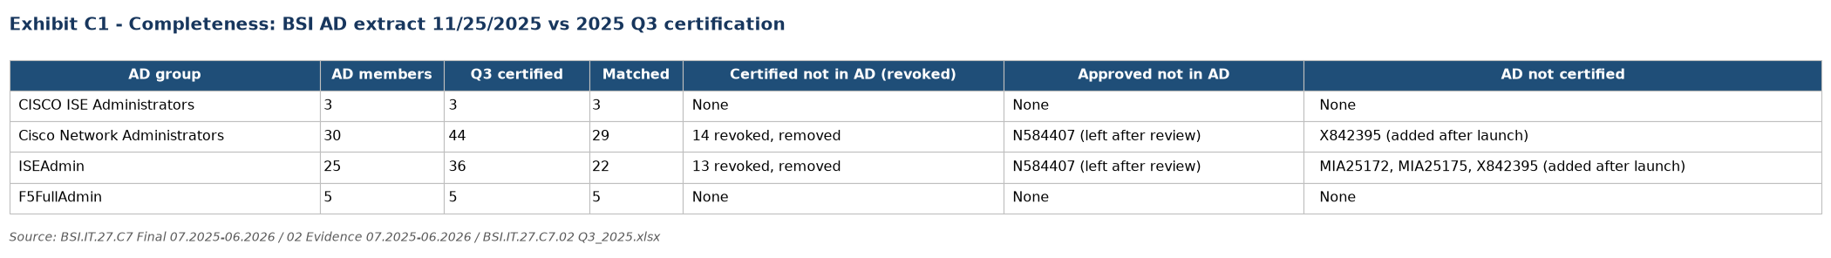
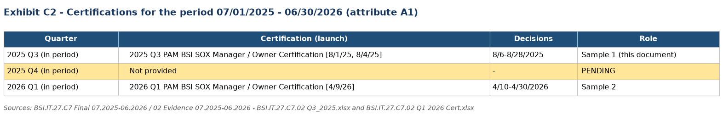
Source: BSI.IT.27.C7 Final 07.2025-06.2026 / 02 Evidence 07.2025-06.2026 - BSI.IT.27.C7.02 Q3_2025.xlsx and BSI.IT.27.C7.02 Q1 2026 Cert.xlsx.

Appendix D - Auditor Testing Narrative and Referenced Workbook
IT RCSA validated the Network Device Admin Account Review control for July 1, 2025 - June 30, 2026 by confirming the privileged network AD groups against the PAM Definition of Privilege, reconciling the 2025 Q3 certification to the BSI Active Directory extract of November 25, 2025, verifying reviewer assignment and decisions, assessing approved access against IAMS identity status and AD account status, and tracing every revocation to the Netwrix removal and to the November 25, 2025 AD extract. Exceptions (A5 and A6) were identified in CISCO Network Administrators and ISEAdmin.
Referenced Excel Workbook: BSI.IT.27.C7.02 Q3_2025.xlsx; BSI.IT.27.C7.05 Testing Walkthrough - Step by Step.xlsx. See Section 4 for the tab-by-tab explanation and reviewer traceability.

